Multi-centric migration model: A case of education facilities for children of Indonesian migrant workers in Sabah, Malaysia

Hanif Abdurahman Siswanto   
*Centre for Policy Research and International Studies*  
*Universiti Sains Malaysia*Pulau Pinang, Malaysia  
hanifsiswanto@student.usm.my

Nanda Harda Pratama  
*Departemen Sosiologi, Fakultas Ilmu Sosial*  
*Universitas Negeri Malang*Malang, Indonesia  
nanda.harda.fis@um.ac.id Joan Hesti Gita  
*Departemen Sosiologi, Fakultas Ilmu Sosial*  
*Universitas Negeri Malang*Malang, Indonesia  
joan.hesti.fis@um.ac.id

Mohammad Reevany Bustami  
*Centre for Policy Research and International Studies*  
*Universiti Sains Malaysia*Pulau Pinang, Malaysia  
reevany@usm.my Seli Septiana Pratiwi  
*Departemen Sosiologi, Fakultas Ilmu Sosial*  
*Universitas Negeri Malang*Malang, Indonesia  
seli.pratiwi.fis@um.ac.id

*Abstract*— In the context of transnational economy, Sabah and Sarawak stand out as exemplary models where there can be opportunities for children of Indonesian migrant workers (PMI) to pursue formal education. In 2023, the statistics show that there are 22,745 students in Community Learning Centres (CLCs) across Sabah and Sarawak. In addition to the number of student enrolment, this also indicates that there is a large number of CLCs that have been established. Hitherto there is little research on this phenomenon, if at all. Against this backdrop, this article has a three-prong objective: (1) to identify the types of CLCs (2) to examine the characteristics of the CLCs? (3) to highlight the differences between the various CLCs and their peculiarities. Multi-centric concept can be applied and defined as transnational relations where there are variety of “centric” that lead toward the establishment of educational institutions for children of Indonesian migrant workers in Sabah, Malaysia. This qualitative research uses deductive research strategy as a logic of inquiry to explore the variety of “centric” among educational institutions in Sabah. Among the key findings are each CLC has a different history and multi-centric actors that led to its existence. Thus, CLC Non-Ladang seem to have a more unique history of their existence that has yet to be explored deeply.

Keywords— Indonesian migrant worker; education facilities; multi-centric; migration

# Introduction

As a whole, Malaysia is known as one of the favorite states where Indonesians look for working opportunities. Based on June 2023 data by Badan Perlindungan Pekerja Migran Indonesia (BP2MI), Malaysia remains as the third states who receive new Indonesian migrant workers after Saudi Arabia and Taiwan [1]. The trend of migration from Indonesia to Malaysia relates with the working opportunity that is available at the present. Despite it was argued that informal sectors such as domestic workers, or child caretakers who often hire female workers causes problems as the government unable to monitor individuals’ employment, currently the statistic shows that many of Indonesian migrant workers are attached to formal sectors than informal sectors as mentioned by BP2MI [1]. The findings show a positive sign for the government of Indonesia as Reference [2] studied that the state had planned to ensure more formal employment than informal employment among Indonesian migrant workers.

Sabah, Malaysia is among the most popular destinations for Indonesian migrant workers or so-called Pekerja Migran Indonesia (PMI). The migration of people from Indonesia to Sabah today is not a new phenomenon but it has been gone through different contexts from pre-Westphalian international system to the current Westphalian system of nation-state which creates domestic and international migration. Most of international migration from Indonesia to Malaysia composes of unskilled or semi-skilled migrant workers which is under the category of foreign workers who works in “3D” (dirty, dangerous, and difficult) workplaces unlike the expatriates [3].

The data does not only finish here as there is a large number of non-citizens children in Sabah that also include the children of Indonesian migrant workers. With regard to Sabah, Reference [4] presented that there are about 250,000 non-citizen children available in Sabah. The data in Reference [5] appeared that about 50,000 to 200,000 so-called “invisible children” in East Malaysia (Sabah and Sarawak) do not have education access. This generalization of non-citizens and “invisible children” refer to whole children who are not Malaysian citizenship. This means that the data refers not only children of PMIs but also children of Filipinos, other citizenship, and so-called “stateless” children. Meanwhile, the data of children of PMIs was stated by Reference [6] that according 2014 data, there were 45,365 children of PMIs. Reference [7] mentions that there are 53,687 children of PMIs in Sabah.

Such large numbers of children of Indonesian migrant workers in Sabah also followed with education facilities. Reference [7] mentions that there are 53,687 children of PMIs in Sabah and only 24,856 of them who received education access. Reference [8] stated that 9,000 from 24,199 children of PMIs currently receive education access from non-governmental organization Humana. Reference [9] informed that 17,000 children of PMIs have received education access in Sabah regardless from NGOs or government of Indonesia.

The concept of multi-centric in international relations discipline refers to a variety of actors who have such capability to influence another actor to act in a particular way [10]. The said concept contrasts with the concept of state-centric which only means that state is the unitary actor who can give an influence of policy change. In this study, multi-centric concept can be applied and defined as actors beyond state in which there are variety of “multi-centric” that lead toward establishment of educational institutions.

This study ascertains the types of CLCs, the characteristics of the CLCs, and the differences between the various CLCs and their peculiarities. To answer the following research questions, the research adopted qualitative research with deductive research philosophy to explain education access phenomena in Sabah, Malaysia. The paper consists of several sections which are literature review, theoretical framework, research findings, discussion and conclusion.

# THEORETICAL FRAMEWORK

## Multi-Centric

The role of nation that is as significant as the state actor. This means that international politics not only based on state-centric but multi-centric. It is believed that nation is an actor separated from state actor, in which not only state that can influence nation to act in a particular way but nation actor itself also has such capability to influence state to act in a particular way.

The said phenomenon opens up the policymakers not only to consider national interests but also to consider smaller interests from the nation itself. As a result, the state government needs to understand more complex interests of many groups.

## Sociological Liberalism

Sociological liberalism theory is about how one nation connects with another nation beyond the traditional role of government-to-government relation and create independent actors [11]. Traditionally international relations discipline mainly focused on state-centric narratives before it was challenged by newer discourses. One of the paradigms which challenges the state-centric discourse in international relations studies is sociological liberalism perspective which enhancing transnational relations. The particular term is discussed in Jackson and Sorensen’s book introduction to international relations, in which it is one of the liberalism school of thought discourses. Among the contributors of the theory and its developments are Karl Deutch (1912-1992), James N. Rosenau (1924-2011), John Burton (1915-2010), and later Philip G. Cerny (1946-present). Transboundary connection creates various political, economy and social activities among themselves. In consequence, nations within one subsystem to another subsystem often sustain the relationship as it gives benefits for both parties [12].

The particular theory is a part of liberalism school of thought which began to rise to against the realist scholars that occurred in the First Major Debate in international relations between realism and liberalism thinkers. Hence, sociological liberalism often associated with Western European’s phenomenon. Sociological liberalism often is used to explain the early phenomenon in West Europe region that transformed from conflict into peace before the establishment of European Coal and Steel Community (ECSC) in 1957 and later European Union (EU). The said paradigm ontologically believes that world of peace can be achieved by having transnational relations. Such multinational organization such as EU in European region will not give any further impact without strong person-to-person relations as the foundation.

Epistemologically, emphasizing transnational relations allow non-traditional security aspects to emerge rather than traditional security as the society and non-state actors involve in having transboundary relationship. Sociological liberalism theory emphasizes the importance of transnational relations in establishing world of peace. The following concepts and theories from several scholars are the foundation of sociological liberalism which can explain how transnational relations influence non-traditional security issues.

# METHODOLOGY

This research is conducted in qualitative research with deductive research strategy. Deductive research strategy is the extension of positivism, known as post-positivism [13]. This research strategy also is recognized as hypothetico-deductive method, falsification, and critical rationalism. The strategy begins with a theory or hypothetical model before collecting data.

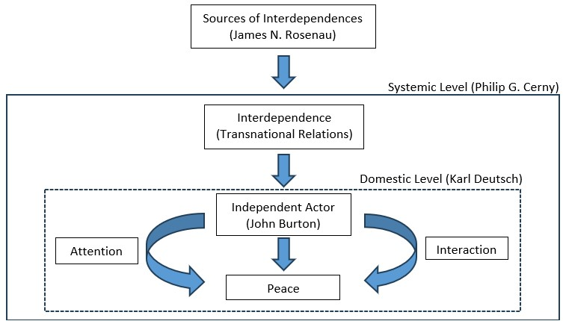

Figure 1.0 Sociological liberalism theoretical framework

The hypothesis or theory then arranges the guidelines of what to measure or what kind of data that will be observed [14]. Figure 1 shows an established theoretical framework of sociological liberalism that is used in the thesis. The particular theoretical framework is a combined perspective from four main scholars of sociological liberalism theory which are Karl Deutch, James N. Rosenau, John Burton, and later Philip G. Cerny. Each of the scholar has contributed to the said knowledge. The established framework works as a guideline for the kinds of data that the researcher should look for. According to figure, therefore the study focuses on the interdependence or transnational relations variable. As the study aims to discover the multi-centric migration model that can explain the number of education facilities in Sabah, hence the research explores the type of interdependence or transnational relations that can be found in studied educational institutions.

For methods to collect the data, the study applied semi-structured interview with Information and Social Culture Affairs of Consulate General of The Republic of Indonesia in Kota Kinabalu, Dra. Machdaniar Nisfah, MBA., and the Liaison Staff of the CLC Consulate General of The Republic of Indonesia in Kota Kinabalu, Nasrullah. Researchers also conducted observation to collect data by observing case study in Kota Kinabalu through visiting Sekolah Indonesia Kota Kinabalu as the headquarter of all Community Learning Centres (CLCs) in Sabah and Sarawak, and “ladang” and “non-ladang” learning centres within the city.

# RESEARCH RESULTS

The research identifies the types of CLCs, the characteristics of the CLCs, and the differences between the various CLCs and their peculiarities. Overall, this study has found that the existence of a large number of community learning centers in Sabah did not happen out of nowhere but it was an existing educational institution that already existed before the existence of Sekolah Indonesia Kota Kinabalu or CLC. To see the role of multi-centric actors involved in the formation of educational facilities for the children of Indonesian migrant workers, the study found that it is not enough to look only at it from the perspective of the Indonesian government and Sekolah Indonesia Kota Kinabalu. The point of view that needs to be seen is actually necessary from the perspective of each CLC because the study found that each CLC has a different history and multi-centric actors that led to its existence. However, it is not denied that many parties such as the educational institutions itself, the government of Indonesia, and other involved actors receive benefit from its establishment.

Overall, the study managed to gain data from four educational institutions and representative of Indonesian government from Consulate General of The Republic of Indonesia Kota Kinabalu. While discussion section shows an explanation of the findings with the applied theoretical framework. In that particular section, the study revises whether the findings are in line with the theory or falsify the theory.

## Consulate General of The Republic of Indonesia Kota Kinabalu

The role of the Consulate General in providing access to education for the children of Indonesian migrant workers is very important. Many previous studies examined the role of the Consulate General in this matter, such as Reference [8] informed that Consulate General of The Republic of Indonesia Kota Kinabalu plays as a representative of Indonesian government in Sabah, Malaysia. Other than representing, KJRI also have such a role in negotiating and protecting [8]. Thus, similar to previous study that other role of KJRI is promoting, in which education that is provided by the government of Indonesia is to promote Indonesia to other nations and to the children of Indonesian migrant workers themselves. It is due to the children of Indonesian migrant workers are mostly born and raised in Sabah. As a result, they have lack of knowledge with regard to their own nationality.

Another government’s representative in Sabah is Konsulat Republik Indonesia (KRI) Tawau located at East Sabah, in which Reference [9]’s research questions touched KRI in Tawau plays its role in administration level as well as socialization to educate Indonesian migrant workers about the importance of documents. Having documents will ease the children’s process towards having fundamental rights such as education access in Tawau. The explanation shows Sabah has the highest representative of Indonesian government compare to other parts in Malaysia. In Malaysia as a whole, Indonesian government representatives consist of one embassy, four consulate general, and one consulate. The embassy is located in Malaysia’s capital city Kuala Lumpur. Meanwhile consulate general are located in Penang, Johor, Sarawak, and Sabah. Whereas consulate is also located in Sabah, Tawau in particular.

In addition, the existence of representatives of the Indonesian government in Sabah located specifically in Kota Kinabalu for the west part of Sabah and Tawau for the east part of Sabah allow easier access for Indonesian people in Sabah to issue formalities and one of them is realizing a large number of CLCs in Sabah. Without the presence of particular representatives of the Indonesian government in Sabah, taking care the legality of the CLCs perhaps is a challenge. Even though Sekolah Indonesia Kota Kinabalu is known as Sekolah Indonesia Luar Negeri (SILN), the school is not under embassy like the other 12 SILNs. Instead, the school is under the Consulate General of the Republic of Indonesia Kota Kinabalu. Moreover, the establishment of SIKK and even CLC are due to different factor compare SILNs in other countries. In the case of other SILNs, Consulate General of The Republic of Indonesia Kota Kinabalu stated that SILN was created to overcome the language barrier for children of diplomats who serve in countries that are not English speaking countries. However, this does not apply in Malaysia because Indonesia and Malaysia do not have a language barrier. This shows that there are indeed other factors that encourage the formation of not only 1 SILN in Malaysia but even 2 SILNs and additional number of CLCs in Sabah.

## Sekolah Indonesia Kota Kinabalu (SIKK)

Sekolah Indonesia Kota Kinabalu (SIKK) among Sekolah Indonesia Luar Negeri (SILN) that can be found in Malaysia other than Sekolah Indonesia Kuala Lumpur and Sekolah Indonesia Johor Bahru but known as the biggest SILN compare to other SILNs. SIKK at Sabah also known as the coordinator of all 294 Community Learning Centres (CLCs) or in Indonesia known as Pusat Kegiatan Belajar Masyarakat (PKBM) across Sabah, Malaysia [15].

Figure 2.0 Model of education facilities for children of Indonesian migrant workers in Sabah and Sarawak

Figure 2 shows a model of education facilities for children of Indonesian migrant workers across Sabah and Sarawak through the supervision of Sekolah Indonesia Kota Kinabalu as the center for all CLCs. Similar with other SILNs, SIKK is highly supported by the Indonesian government. However, this does not mean SIKK only relies significantly on government. The study found the importance of multi-centric actors in contributing towards the success of SIKK.

Among the importance of this multi-centric relationship that can be seen at SIKK is the existence of the "*pokok e belajar*" association. This association is one of the innovations created by teachers from SIKK and other CLCs when the Covid-19 epidemic began. The group's membership consists of teachers from SIKK and CLCs whose functions is to provide learning materials during the Covid-19 outbreak for pupils. In fact, there are positive impacts from this multi-centric relationship between teachers, in which firstly the pupils will be given material by teachers who are experts in their field. For example, mathematics lessons will be taught by teachers who specialize in mathematics. It is very difficult to implement on normal days because every CLC tends to have a lack of teachers. This causes a teacher has to teach several subjects even though it is not his or her field. Secondly, this study has found that the innovation has been used as the basis for *Pendidikan Jarak Jauh* (PJJ) or known as distance learning for junior high school students (SMP) in Sabah and Sarawak. With the relationship between existing teachers, SIKK can further increase access to education for the children of Indonesian migrant workers in the surrounding area. The PJJ program should be able to further increase the number of children to get access to education.

The research also found how sustaining relationship between the school and alumni is useful for educational development. This particular multi-centric actors also played significantly especially during the pandemic time where SIKK used the said relations to establish so called “smart parenting”. The smart parenting program is a sharing session by alumni who studied in SIKK or CLC towards parents of the pupils. The role of alumni is very important as it is from there that both school pupils and parents can see the effect when someone gets access to education and completes to a higher level. Specifically for parents as the audience, it is important to give parents awareness of the importance of education for their children. Parents are a child's first gate to obtain knowledge.

Based on interview, there are also other efforts taken by SIKK to gain more multi-centric relationships for partnership regardless of the type of collaboration. The partnership can be in the side of medicine, education, finance, and other type of collaborations.

## Community Learning Centre (CLC) Non-Ladang

Community Learning Centre Cerdas or known as CLC Cerdas is one of CLC Non-Ladang as can be seen in figure 2. The figure 2 shows that there are two types of CLC which are CLC Ladang and CLC Non-Ladang. The study found that CLC with Non-Ladang categorization are different to each other, in which every CLC Non-Ladang has its own historical background and multi-centric relationship that led to its establishment. Figure 3 shows the establishment of CLC Cerdas on 26 January 2017.

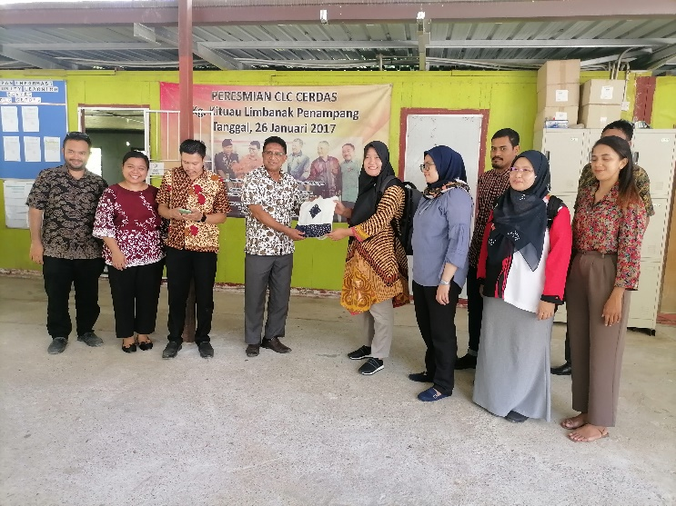

Figure 3.0 Visiting Community Learning Centre Cerdas, Penampang

Despite the establishment of CLC Cerdas was in 2017, the study found that the learning centre has been established earlier than the stated year. According to the learning centre’s principal, this particular learning centre was established since 2010 with the partnership of religious entity from Catholic Church as the principal was known as Ketua Katolik Indonesia. At the early stage of opening, the learning centre rented several rooms at Secretariat Cathedral building for 7 years before it moved to a new rental outside the said building.

While another CLC with Non-Ladang categorization that the researcher visited is CLC Grace Center also shows the same tendency. The study has found that this learning center existed even before the existence of SIKK. According to the results of the interview, this learning center exists under the auspices of the Basel Church Malaysia from Switzerland that arrived in Sabah in 1881. This learning center was then established in 2005 under the name Grace Center located in Penampang. However, in 2006 it moved to Keningau under the name Goods Samarithan Home before finally moving again to Kota Kinabalu in 2013. Finally in 2016, this learning center officially became the CLC Grace Center. Other than Basel Church Malaysia, the centre is also supported by community from South Korea, in which they also often visit the centre monthly.

## Community Learning Centre (CLC) Ladang

The study found that there is a difference of actors involve in CLC Ladang and CLC Non-Ladang. This study visited the CLC Ladang Mawau as a sample of CLC Ladang type. The particular CLC is different from other visited CLC Non-Ladang, in which the study could not find multi-centric actors other than the oil palm estate itself. Figure 4 shows a signboard of CLC Ladang Mawau that is owned by Sawit Kinabalu Sdn. Bhd. The result does not contradict with previous studies where oil palm or plantation companies were directly involved in providing access to education for the children of Indonesian migrant workers. Reference [9] found that oil palm plantation companies accommodating the fundamental rights that include education access for the children of PMI as a Corporate Social Responsibility (CSR) initiative. Oil palm plantation companies mostly contribute to provide educational infrastructure as well as collaborating with Guru Bina and Consulate General to recruit local teachers or also known as Guru Pamong [16].

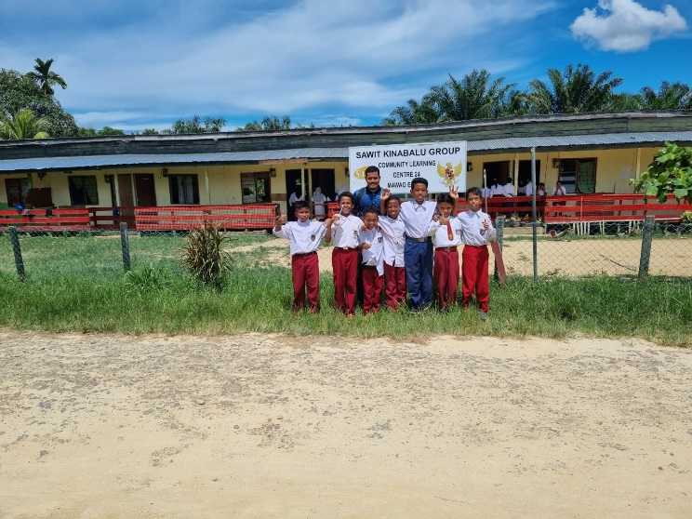

Figure 4.0 Visiting Community Learning Centre Ladang Mawau, Beaufort

# DISCUSSION

The research examines the existence of multi-centric model that can be found within the studied learning centre. The results of this study have found that there are differences between CLC Ladang and CLC Non-Ladang. Based on the research, CLC Ladang is clearly owned and managed by an oil palm plantation estate. Whereas different findings were found in the CLC Non-Ladang. As they do not belong to a particular oil palm plantation estate, CLC Non-Ladang seem to have more unique history of their existence that have yet to be explored deeply. The research found that often previous studies centralized their perspectives from the view of Consulate General of The Republic of Indonesia and Sekolah Indonesia Kota Kinabalu (SIKK) but lack of study found in raising the history or perspective of each CLC in Sabah and Sarawak. This is because the study found that each CLC Non-Ladang in particular has its own history of establishment, connections, relationships or multi-centric actors that help in establishing the educational institution.

Deductive research strategy is a research which aims to verify a particular knowledge. It is also known to test a theory or hypothesis whether to the results are in line with the theory or rejects the theory. From the results and findings, the research found that the results are in line with the applied sociological liberalism theory. Based on the findings, perhaps CLC particularly CLC Non-Ladang categorization is an independent actor. The CLC Non-Ladang actually is not connected to each other and they are an independent actor as the research found that each of them has its own historical pattern and transnational relations. For instance, individual A conducts interdependence with organization B and leads to an establishment of educational institution. While individual C conducts interdependence with organization D and forms another educational institution.

The total number of CLCs across Sabah and Sarawak might also play a significant role. On one hand it shows that there are many transnational relationships happen in the region. The reason is that if the findings is used to generalize the data, the number of CLCs especially CLC Non-Ladang will also represent the interdependence occurrence. On the other hand, from the figure 2 it shows that despite only CLC Ladang certified by Ministry of Education Malaysia, CLC Non-Ladang remain to operate although without such legalization from the government of Malaysia. Based on the interview, the study also noticed the narrative of teachers who narrated police who often went to the institutions asking for an explanation. This also in accordance with sociological liberalism theory as the number of independent actor matters in forming peace. In other words, there seems to be a lack of legal action by the Malaysian government as there are too many CLC Non-Ladang that can be found in Sabah and Sarawak which causing them to give lesser attention over one particular CLC Non-Ladang.

# CONCLUSION

This study aims to identify the types of Community Learning Centres (CLCs). Another purpose is to examine the characteristics of the CLCs and to highlight the differences between the various CLCs and their peculiarities. Our findings have revealed all objectives, thus the results have interesting discoveries on filling the gap of research with regard to the particular phenomena.

Based on the research, overall, the study found that CLCs are separated into two categories, which are CLC Ladang and CLC Non-Ladang. The interesting discovery lies on the difference that is not only based on the geographical location of the CLC such as CLC Ladang is located at plantation area while CLC Non-Ladang is outside plantation estate. The difference goes to an extend that often each CLC Non-Ladang has its own historical pattern and transnational relations beyond state-centric discourse. As a result, perhaps there is a need to understand historically how educational institutions developed by Churches in Sabah at the early stage of its establishment.

Unfortunately, the samples should be furthered increase in future studies in order to strongly generalize overall results. Thus, this study recommends further research on discovering the establishment of other CLCs across Sabah and Sarawak. There are still a lack of study in ascertaining the particular inquiry.

##### ACKNOWLEDGMENT

Thank you for the opportunity of joining a joint research as a research assistant funded by Universitas Negeri Malang. In this opportunity, the team would like to thank you to Assoc. Prof. Dr. Mohammad Reevany Bustami for being co-author and giving inputs to this study.

##### REFERENCE

1. BP2MI. (2023, July 5). *Data penempatan dan perlindungan pekerja migran Indonesia Periode Juni 2023*. <https://bp2mi.go.id/statistik-penempatan>.
2. Nuraeni, Y., and Suryadi, S. (2021). Strategy for the development of the Indonesian migrant worker (PMI) placement program in the formal sector. *Italienisch, 12*(1), 12-22. <https://italienisch.nl/index.php/VerlagSauerlander/article/view/167>.
3. Aminuddin, M. (2020). *Comparative study on laws and policies in the management of migrant workers in ASEAN*. Jakarta: The European Union Mission to ASEAN.
4. Loganathan, T., Chan, Z. X., Hassan, F., Ong, Z. L., Majid, H. A. (2022). Undocumented: An examination of legal identity and education provision for children in Malaysia. *PLoS ONE, 17*(2), 1-26. 10.1371/journal.pone.0263404.
5. Muslihuddin, M., Hussin, R., Retno Wulan, T., and Santoso, J. (2023). The role of Non-Government Organizations in the education of migrant workers' children in Sabah Malaysia. In *2nd International Conference on Politics, Social, and Humanities Sciences (ICPSH22)*, 363-373.
6. Anita, A., Darwita, D., and Baharuddin, A. (2021). Kerjasama Indonesia Malaysia dalam peningkatan taraf pendidikan anak TKI di negeri Sabah. *Hasanudin Journal of International Affairs, 1*(2), 193-216. <http://etd.repository.ugm.ac.id/penelitian/detail/60808>.
7. Christie, D. (2016). Upaya Indonesia dalam menangani pendidikan anak tenaga kerja Indonesia di Sabah Malaysia. *eJournal Ilmu Hubungan Internasional, 4*(4), 1161-1176. ejournal.hi.fisip-unmul.ac.id.
8. Andita, L. R., Damayanti, C., and Suryo, H. (2016). Peran KJRI Kota Kinabalu dalam meningkatkan akses pendidikan bagi anak-anak buruh migran Indonesia (BMI) di Sabah. *Transformasi, 1*(30), 150-161.
9. Sholina, C. A. (2022). Pemenuhan hak-hak asasi anak Tenaga Kerja Indonesia di perkebunan sawit Di wilayah Tawau, Sabah, Malaysia. *Jurnal Pembangunan Manusia, 3*(1), 1-20. 10.7454/jpm.v3i1.1029.
10. Jackson, R., and Sorensen, G. (2013). *Introduction to international relations: Theories and approaches 5th edition*. New York: Oxford University Press.
11. Deutsch, K. W., and Singer, J. D. (1964). Multipolar power systems and international stability. *World Politics, 16*(3), 390-406.
12. Rosenau, J. N. (1984). A pre-theory revisited: World politics in an era of cascading interdependence. *International Studies Quarterly, 28*(3), 245-305.
13. Blaikie, N. (2000). *Designing social research: The logic of anticipation*. Cambridge: Polity Press.
14. Casula, M., Rangarajan, N., and Shields, P. (2021). The potential of working hypotheses for deductive exploratory research. *Quality and Quantity, 55*(5), 1703-1725. 10.1007/s11135-020-01072-9.
15. Wahyudin, U., Hufad, A., Purnomo, P., and Sulistiono, E. (2021). Community Learning Center (CLC) service improvement for expatriate children. In *Proceedings of the First Transnational Webinar on Adult and Continuing Education (TRACED 2020)*, 112-117. 10.2991/assehr.k.210508.021.
16. Annisa, R. N., and Nizar, M. (2022). The Indonesian Government’s diplomacy in fulfiling the education rights of the children of Indonesian migrant workers in Tawau, Sabah Malaysia. *Journal of Paradiplomacy and City Networks, 1*(1), 39-53. 10.18196/jpcn.v1i1.1.